National College of Ireland

BSc in Computing

2014/2015

Sean Hoey

X11000759

sean.p.hoey@gmail.com

Fight Utopia

Technical Report





**Table of Contents**

Executive Summary 3

1 Introduction 4

1.1 Background 4

1.2 Aims 4

1.3 Technologies 5

1.4 Structure 6

2 System 7

2.1 Requirements 7

2.1.1 Functional requirements 7

2.1.2 Data requirements 8

2.1.3 User requirements 8

2.1.4 Environmental requirements 9

2.1.5 Usability requirements 9

2.2 Design and Architecture 9

2.3 Implementation 11

2.4 Testing 15

2.5 Graphical User Interface (GUI) Layout 16

2.6 Customer testing 17

2.7 Evaluation 18

3 Conclusions 19

4 Further development or research 20

5 References 21

6 Appendix 22

6.1 Project Proposal 22

6.2 Requirement Specification 29

6.3 Monthly Journal 43

6.4 Other Material Used 50

# Executive Summary

Fight Utopia is a RPG (role-playing Game) created in unity 3d aimed at gamers who like to play RPG style game with a combat system. My inspiration for this game was taken from games like Batman Arkham series and assassin’s creed series.

I decided to develop my game in unity as I been working with it for the last year and have come to like it. It free and has lots of resources to learn from. I created my model over in Maya and then I ported it over and animated it in unity.

I create my game to be used with the Oculus rift optionally as I thought it be a unique selling point for my game. Along with it being a really cool hardware to work with. I feel the Oculus Rift is the next step in gaming by bringing players closer to the action and allowing them to become the character.

I had a few problems to deal with creating my game. One of These problems was being able to see if a player was actually in range to throw an attack so I use the ray cat function in unity. So what a ray cast does is create an invisible line out in a given direction and give back the object and distance of the first object that is intersected.

# Introduction

## Background

The reason I decides to create this game is that I’m an avid gamer and I always want to create a video game of the same calibre as most AAA games out there at the moment. The game industry has gone through many changes in recent years. The main reason for this is the development of VR headsets which allow players to get closer to the action and makes the player feel like they are the character. Which I thought be nice to include in my game.

I took inspiration from games like Batman Arkham series and assassin creed series these games do rely on it storytelling which I did not really focus on but have left amply room to include a story. That these games do bring is a great gameplay mechanics which I wanted to bring to my game. I did leave out the stealth gameplay these game have as many game have these in them and it sometimes feel they were added only for the sake of it.

## Aims

The aim of this project is to make a fully functional RPG with a hand to hand combat system in a 3D virtual world. The game will contain all functionalities expected of a modern AAA game. The game will allow players to take control of the main character and fight their way through enemies till they are strong enough to defeat the ruler of Tournaville.

The game is able to change the difficulty of the enemies as the player level up. As the enemies get hard the more Experience the player will gain. As well as increase the amount of experience points depending on their highest amount of combo the player achieves against an enemy.

Players will be able to buy items form the shop to use against enemies. Player will receive coins from defeated enemies to use in the shop.

## Technologies

I used various technologies in my project these include:

* Unity
* C#
* Visual Studios
* Maya
* Oculus Rift

I chose unity to program in as part of my work experience I learned how to use Unity. Unity is a great program as it easy to use and has a large community of programmer willing to help and answer any question you have. Another reason is its free software anyone can download and use freely, as well it has its own assets store where users can download or upload their own assets like models, code and other APIs.

C# is the one of the main languages used in Unity it is very similar to java making it easy to transfer over to. Again with unity I only started to learn C# as part of my work experience but quickly came to love the language. C# is a very easy language to use and can get a lot of functionality out of it, combining it with the set component in unity allow anyone to create game with a lot of polish.

I used Visual Studios instead of Mono Development which come with unity as my version of mono development decided to corrupt while updating unity. I also found visual studio was a lot more intuitive to work with and nicer to use.

Maya is modelling program that I was introduced this year. This is program allows users to create model of object, building and character usually ones that are ported to video game. I mostly used this to create character and give animation to one of my character. It is a fun tool to us and thanks to Digital-Tutors really easy to learn.

Oculus rift is a virtual Realty headset that allows you to view a virtual world through your own eyes. I have had an interest in VR headset and had the chance to use one for the first time this year as part of my computer graphics and animation module this year. This was relatively easy to add to my project as oculus VR have started work with Unity to create a very simple integration process that allows any user to added to they’re game.

## Structure

In this first section of this report I discuss what the background of the project along with my aims and the technology used to create my project.

The second section focuses on the classes, structured used in the project and the requirement I decided was necessary for my project. I also go into how I implemented my project and describe some of the code used in the project. Then I show the GUI used and the testing used throughout the project.

Then the third section I write my conclusion of what I learned and some of the advantages and disadvantages of the work done on my project.

The fourth section describes the future development I feel I could make to my project. These could be the changes I would make or the additional function I would add to the game.

In the fifth section contains my references of resources I used though out the development of my project and finally in the Sixth section is my appendix containing previous submitted document and any other information that needs to be given.

# System

## Requirements

### Functional requirements

**Start Game**

This allows player to start the game for the very first time. Where they will start at square one and move on from there.

**Load Game**

This function lets returning player to load there previous save and continue their progress where they left off. The game is able to keep track of the player’s progress and stats. So a user can play for a certain amount of time then quit and return play from where they left off.

**Change Camera**

At the start menu you are given the option to use the normal game camera so if you not using the oculus rift you can play the game normal for the screen of the computer or they can change the camera so they can use the oculus rift to play the game.

**Save Game**

This requirement allows user to save their progress throughout the game and return to that save point at any time. The game also auto saves when you have levelled up

**Quit Game**

This just allows player to quit the application and return to their desktop.

**Combat System**

This will allow the players to fight with the NPC and will count how many combos the player achieve against an enemy.

**Level Up**

As the player defeats enemies they should gain experience to level up. This has changed slightly as player attack will get strong and enemies will get stronger depending on your level. Player will not gain skills or combat moves.

**Health System**

The player has a certain amount of health which will increase as the player levels up. Players lose health point by getting hit by enemies in the game but the player will be able to restore health with health potions bought from the shop.

**Items**

Players will be able to get items from shops. The items have various uses that will give the player advantages over the enemies AI. Some of these items will be health potion to restore health or a smoke bomb that will confuse the enemy for a few seconds.

### Data requirements

All Data is saved into an external XML file. The file monitors the player’s level, score and coins they have collected. Information is only save when you level up or save the game, no information is saved outside the game. This XML file is saved in the %APPDATA%\LocalLow\DefaultCompany Folder.

### User requirements

The system Requirements from a user side include:

* User has a computer.
* User has a ps3 controller.
* Windows Operating system.
* Fight Utopia downloaded onto the computer.
* Better DS3 running on their computer.

### Environmental requirements

In order to play the game will need to have window operation system installed on their computer. Optionally if they want to use the oculus rift they will need the Oculus rift SDK installed and set up on your computer.

### Usability requirements

What the users need to know to play this game is:

* Understanding on using a PlayStation 3 controller.
* Navigating a character through 3D space.

## Design and Architecture

**Use Case Diagram**

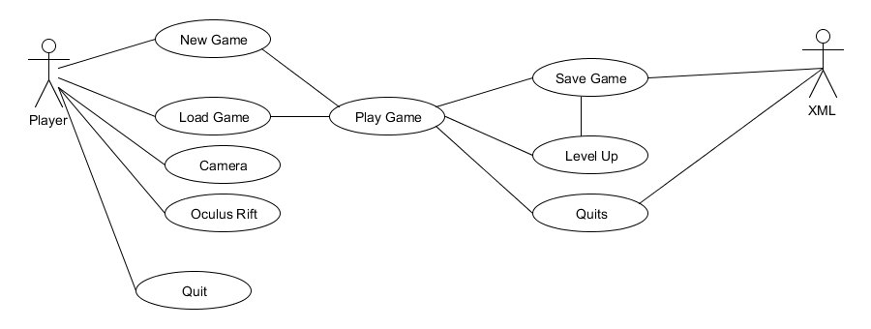

When the user starts the game they will be brought to the main Menu and given either 4 option if it’s the first time playing or 5 if the user is a returning user. The New Game option will start the game fresh and the user will start at level one. Load game will appear if the user has a previous save this will load the game as normal but the user will have all there stats from the save carried over and won’t start from level one. Camera option when selected tells the game the user is playing the game through the screen of the computer and will use a normal virtual camera to view the virtual world. The Oculus rift option will tell the game the user is using the Oculus rift set up to play the game and replaces the normal virtual camera set up in the game with camera use for the oculus rift. The quit option will stop the application and return the user to their desktop.

**Class Diagram**

**Main Menu**

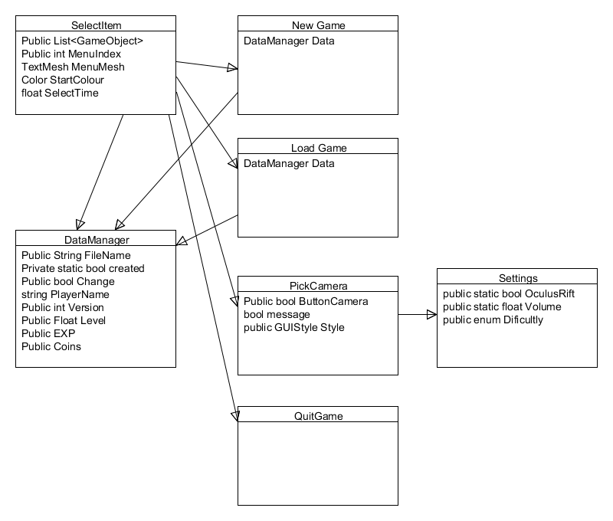

**Main Game**

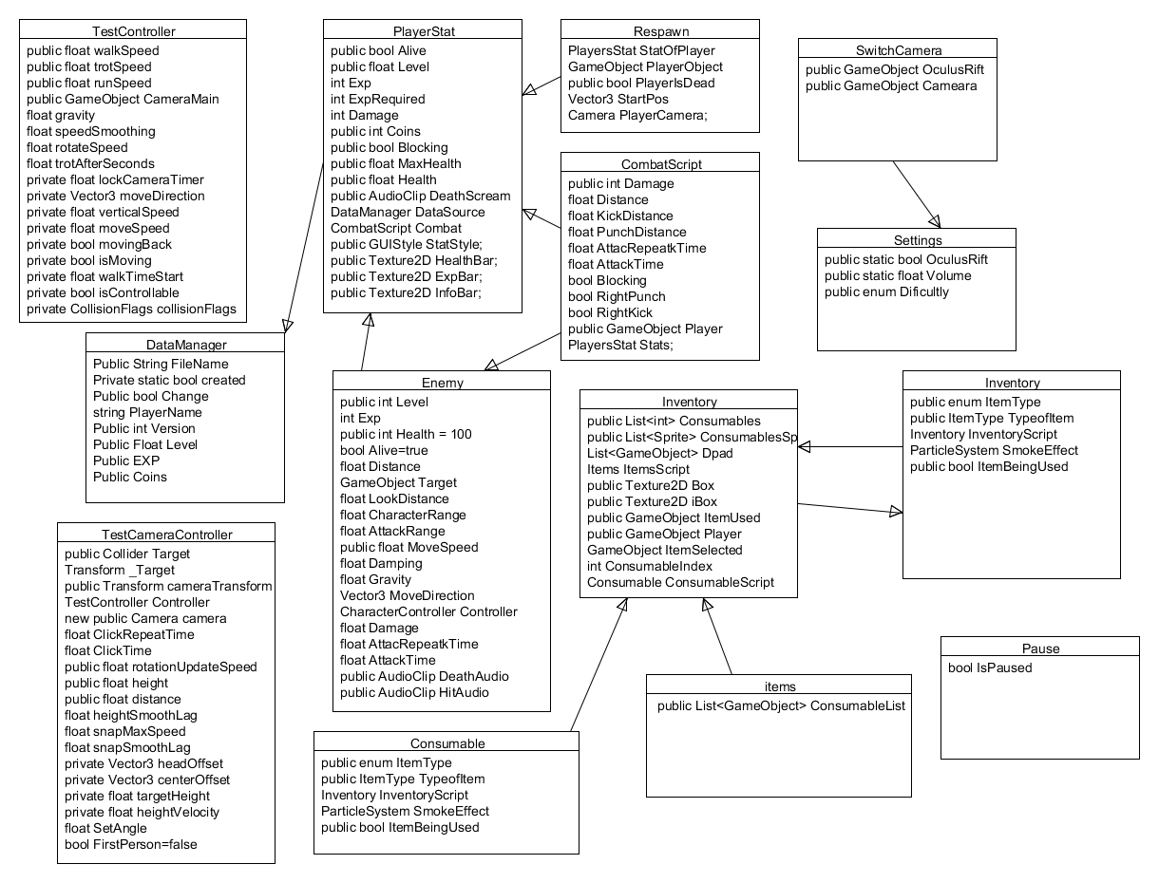

## Implementation

Unity is a great program to use to create games. It has its own hierarchy than most programs allowing unity to pull of some helpful and useful function. The hierarchy works with Game Object stored in a scene these object can be character, camera empty object that only hold scripts, buildings, camera etc. Game objects stores there position, scale and rotation with in the scene unless they are a child of a parent object then there position, scale and rotation are relative to the parent object. Unity also has its own inspector that show script, colliders, materials, audio etc. You are able to edit attribute of any attached item that is attached to the Game Object including public variable of scripts.

**CombatScript.cs**

The combat script Checks if the player is close enough to a target when they throw an attack that they are able to hit. The way I did this is shown below, the ray cast goes from out from the player in the direction it is facing and returns the distance its travel before it hit another object if the object is within distance in send a message to that object to apply damage and the variable of how much dame it deals. If the model it hits contains the function apply damage the damage is taken off that health until it reaches zero.

if(Physics.Raycast(transform.position,transform.TransformDirection(Vector3.forward),out hit)){

Distance=hit.distance;

print(Distance);

if(Distance<PunchDistance){

hit.transform.SendMessage("ApplyDamage",Damage,SendMessageOptions.DontRequireReceiver);

}

}

**PlayerStats.cs**

Player stat contain the entire for the player variable like health, EXP, coins and damage it can deal. It also contains the function that takes away from the player health. This function shown below is called when the Enemy is close enough to attack if the player is hit with the attack and the player is blocking shown by the Boolean the player only takes quarter of that damage if not full damage is done. It also checks if the player health is above zero and when it is zero or below called the dead function.

void TakenDamage(float Damage){

if(Alive){

audio.Play();

if(Blocking){

Damage=Damage*0.25f;

}

Combat.AddAttackTime();

Health-=Damage;

if(Health<=0){

Alive=false;

Dead();

}

}

}

**PickCamera.cs**

This script deals with setting up what virtual camera, the player select an option main menu and depending on that option is tells the setting script which a static class that holds a variable to be called on when the next level is started.

public void SelectCamera(){

if(ButtonCamera){

Settings.OculusRift=false;

}

else{

Settings.OculusRift=true;

}

print(Settings.OculusRift);

StartCoroutine(ShowMessage());

}

**Enemy.cs**

This script is control the enemies the player will face in the game it hold a number of functions. Below is the code for update, the enemies know where the player is at all-time but do not act on this information until the player is within a certain distance ash shown below.

void Update () {

if(Alive&&Target.activeSelf==true){

transform.eulerAngles=new Vector3(0,transform.eulerAngles.y,0);

Distance=Vector3.Distance(Target.transform.position,transform.position);

if(Distance<LookDistance){

LookAt();

}

if(Distance<AttackRange){

Attack();

}

if(Distance<CharacterRange){

Chase();

}

}

}

The lookAt Function just simples rotates the object around until it is facing the player, when the player is closer the Chase function moves the object closer to the player and finally when the object is close enough to attack the character the Attack function is called.

This script also holds the Enemies health and Apply damage function I mentioned earlier. It is very similar to the TakenDamage function in the playerStat.cs

void ApplyDamage(int Damage){

if(Alive==true){

audio.Play();

Health-= Damage;

AttackTime = Time.time + AttacRepeatkTime;

if(Health<=0){

Alive=false;

StartCoroutine(Dead());

}

}

}

**Inventory.cs**

This script holds all the player consumable that they have acquired. It contain a list that keeps track of how many of each item the player has and the GameObject of the item so when the player uses the it know what item and calls the effect of that item.t To use an item the UseItem function is called it check to see if the player has any consumable, then it find the index of the item from there is creates the object at the player location then access the Consumables script that hold the function for what that function is e.g. Health potion

public void UseItem(int itemId)

{

if (Consumables.Count > 0)

{

GetItem(itemId);

Consumables.RemoveAt(ConsumableIndex);

if (itemId == 1)

{

ItemUsed = (GameObject)Instantiate(ItemSelected, new Vector3(Player.transform.position.x, 0, Player.transform.position.z), Quaternion.identity);

ItemUsed.transform.eulerAngles = new Vector3(270,0,0);

}

ConsumableScript = ItemUsed.GetComponent<Consumable>();

ConsumableScript.ItemBeingUsed = true;

ConsumableScript.ItemAffect();

}

}

## Testing

I mostly used unity to test my game. Unity has its own debugger and compiler it lets you know any errors in your code and warning of unused variables. Along with this we have functions like Debug.Log() which can be placed in our code and give is back variable and there variable values letting you run through your code. Along with this I used the breakpoint system in visual studios where you can but breakpoints on certain lines of code. What this does is while you are running the game when any line of code that has a breakpoint on it is called, the game will pause itself and visual will appear. This also shows you when the line of code is being called if it’s being called to early or too late. As well as showing the values of any variable declare in the line of code.

I did also conduct some verbal User testing with some student from class and friends. This is very useful as while developing games programmer look out for specific output and functions to happen. This can lead to error or glitches to happen without the programmer to notice.

## Graphical User Interface (GUI) Layout

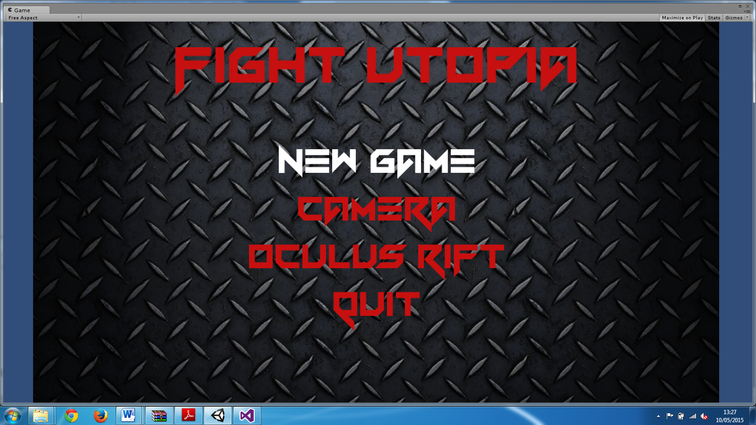

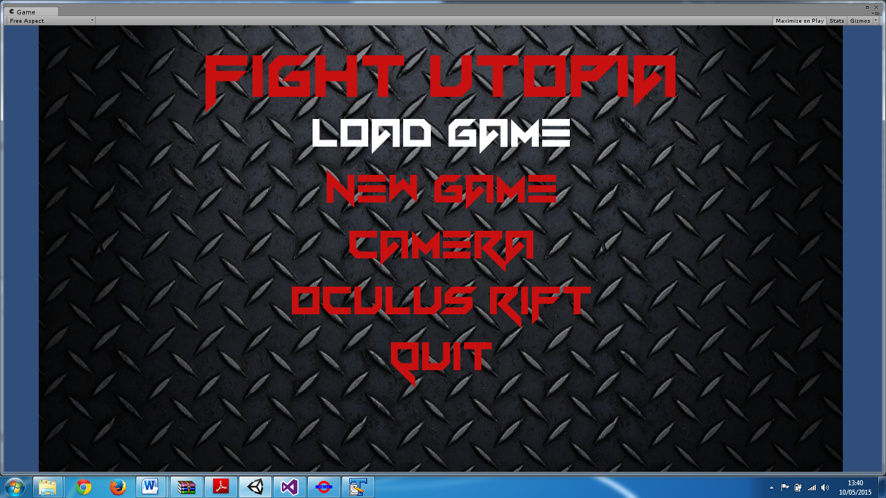

Above show the two states of the main menu the first being the menu when a user starts the game for the first time. The second shows when a returning user start up the game and the load game option is revealed. The white text means that the player is currently on that option with the left analogy or D-pad the user can move up and down the list of option.

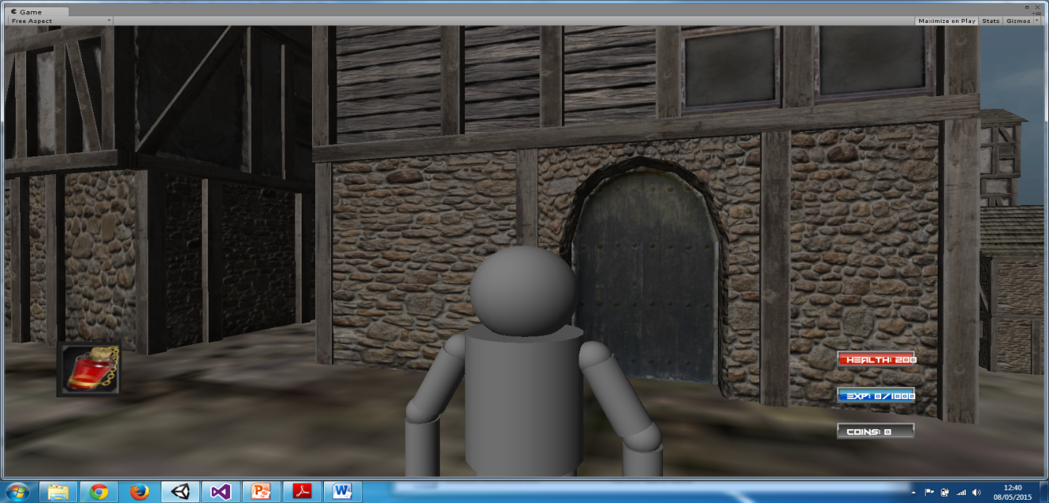

Here shows the GUI in game where players are shown the item they are using on the left and there other stat that include health, experience and coins they have collected.

## Customer testing

Provide evidence for and results of customer testing. This may include ratings or quotes from the customer.

During my testing with some user I got some great feedback. Some of my users had experience coding and some who didn’t. They were able to give feedback on my game.

One of the problems that were commented on was switching camera from first person to third person to do this you clicked down on the right analogy stick (R3). What they noticed is sometime the game would register multiple clicks and the camera would switch multiple time and then stop on either on first person or third person. To fix this problem I added a time parameter that only allow the game to register another click after a couple of second this stop the problem of multiple click.

Another error that was commented on was problems with the animation. Users could stop an animation of the main character. An example of this is if a user did a right kick the user could stop it and do a left kick and stop that animation too so it look like the character was driving an invisible car. To fix this I sped up the animation and locked the animation so the user could do another action till the animation was completed

## Evaluation

I have mostly evaluated the project by running looking at the console in unity for any errors in my code along with using the breakpoints in visual studio to make sure the all code work together in the proper manner.

I had a few testers look at the game and most feedback was positive apart from the few errors that game up. All testers they said they liked the game and would play it again.

# Conclusions

I really enjoyed making the game this was my first time making a game in unity in 3d I have mostly been making game in 3d. The main reason I choice Unity and the programming language of C# was my previous experience working with it in my work experiences which was a real advantage, Along with it massive community always on hand to give advice and help with code.

I did have problems with creating models in Maya but thanks to looking up tutorials from Digital-Tutors. This gave me a greater understanding of Maya modelling tools along with creating better models that before.

Another issue I face was the transition to creating games in 2D and 3D. I had no real experience making games in 3D but I quickly adapted and relished the chance to create a game similar to AAA game that are out there.

I choice to great a game for my final project as I want to go on to create or work on AAA game in the future. I am also an avid gamer an thing it quite a unique medium to show a story as you can only progress through the story by being good at the game and completing the section the player is currently on.

I also added the Oculus rift as it a fairly new technology which is growing by the day. More and more there are other version of VR headsets bring create and it seems to be the future of computer display along with gaming. I grew interested in using the Oculus rift in my game after it was introduced to me in our computer graphic and animation module this year, I also would like to work more with similar technology.

# Further development or research

There are a lot of changes I could make to improve and expand my project. Firstly would be to develop a story arc for the game along with creating and modelling more realistic character. I would need to research more into creating models and texturing model in Maya. As I only have the student version of I would need to either buy the full version or even download a free alternative.

I also would like to create a bigger map for the player to move around in, along with a climbing system that would give the player full exorability of the game 3d world. To do this id need to create more building and areas to explore, this would also mean looking at a fast travel system so player can traverse through the world with ease.

I would like to see my game become a Massive Multiplayer Online (MMO) game where players from around the world could play with or against each other. Giving the game a longer lifespan and coupled with DLC more replicability.

My game is being developed on Windows PC platform at the moment. In the future I would like to adapt it to port it to other platform like Xbox and PlayStation. For this to happen I would like to have the games to be downloadable for the relative store available. For PC this would be the likes of steam or if possible have it as a Facebook app player making the game a unity web player. I have experience making and releasing games on Facebook the process is easy and free for anyone to do. Xbox have looked into increasing the indie games marketplace making it easier for programmer to release there game on to the Xbox marketplace for anyone to download. This is the similar to for releasing a game on the PSN.

# References

Art, O. G. (n.d.). Retrieved October 2014, from http://opengameart.org/

Brackey. (2014). *How to make a survival Game - unity Course*. Retrieved December 2014, from YouTube: https://www.youtube.com/playlist?list=PLPV2KyIb3jR7F_B4p8X3YwHPaExh0R9Kk

Font, D. (n.d.). Retrieved Septemper 2014, from http://www.dafont.com/

Green, K. (n.d.). *Beginner's Guide to Maya*. Retrieved September 26, 2014, from Digital-Tutors: http://www.digitaltutors.com/tutorial/512-Beginners-Guide-to-Maya

StackoverFlow. (n.d.). Retrieved September 18, 2014, from StackoverFlow: https://stackoverflow.com/

Unity. (2004). *Learn with unity*. Retrieved September 2014, from http://unity3d.com/learn

unity. (n.d.). *Unity Asset Store*. Retrieved September 2014, from unity3d: https://www.assetstore.unity3d.com/en/

Ward, A. (2001). *Creating a Low Poly Game Character in Maya and Silo*. Retrieved April 21, 2015, from Digital Tutors: http://www.digitaltutors.com/tutorial/689-Creating-a-Low-Poly-Game-Character-in-Maya-and-Silo

# Appendix

## Project Proposal

Project Proposal

**Fight Utopia**

Sean Hoey, x11000759, sean.p.hoey@gmail.com

BSc (Hons) in Computing

Gaming and Multimedia

26/09/14

* **Objectives**
* **Background**
* **Technical Approach**
* **Special resources required**
* **Project Plan**
* **Technical Details**
* **Evaluation**
* **Consultation with Project Specialization Coordinator**
* **Consultation with Academic Staff**
* **Proposed Supervisor**

1. **Objectives**

The objectives of this game as shown below:

My objective is to create a third person free roaming close combat game within either unity or unreal engine 4. To do this I will begin creating simple scene together for testing the game mechanics, AI get an idea of what I want the scenery to look like.

I will most likely use the standard assets in the game engine to create the sky and lighting but create the rest of the assets in Autodesk Maya.

I want to have Three main AI created at the end of the project one to be a friendly AI that will help you along the game and fight with you. The second AI to be an enemy that you will have to fight and defeat and finally a neutral AI that can be used for random characters in the game or shop who can fight back if the players attack.

By the end I want to have a pretty big area for players to explore and move around the area quickly. So I will have to create some kind of fast travel point and I might add a parkour system like in the assassin’s creed series.

There will also be equipment and item that players will be able to pick up and use i.e. amour and health packs.

I would like if I have time to make the game a massively multiplayer online game and allow player to design their characters and create faction that fight against each other online.

1. **Background**

The inspiration for my game came from some of my favourite games.

I am a big fan of the assassin’s creed and the batman arkham series. Both these game have stunning open world map along with a great combat mechanic which allows player to attack the problem of getting past enemies in either an out frontal attack or sneak past and take out your enemies.

I want to have my AI to be a Leaking buckets AI so that they can be activated by event and have a set of goal to follow and achieve throughout the game or they’re life time.

So far in week three I’ve been mostly looking at Maya and how to create model mostly characters so I can start working on movement behaviour and the fighting system. I want my characters to look and reacted as real as possible.

I intend to make just one male character for the protagonist and allow players to pick the characters fighting style these will change the character attribute, special moves and skills. This will hopefully allow the game to be more repayable and make the game feel a little fresher with every play.

The main menu will be simple just have buttons to start new game, load a previous game session and an exit button to exit out of the game. I hope to also have the game using controller as I want to go into the console side of computer gaming development.

1. **Technical Approach**

**Research:**

I started researching with looking at Maya and how to create realistic model. I want to give my game new immersive world to engross them into the game. After I get to grips with that I want to look at taking input for a controller use that input to control a character in a scene then work from there.

I will also have to research which game engine to use. I have used unity engine for the six months in my work placement and am very proficient in using unity and writing in C#, but I do want to take a look at the unreal engine 4 and see how that compares to Unity.

I have to look into how games handle creating a game that is open world. I already have an idea to tackle this by having the game only load a certain radius of the area around a player. This will allow me to destroying areas around the player that is not needed and load the area a player is currently playing in.

**Requirement captured:**

* User Interface
* Health
* Energy
* Mini map
* Pause menu
* Main menu
* Quests
* Side Quests
* Mapping
* Dialogue
* Levelling system
* Equipment system

**Implementation:**

I will be implementing the project by using C# and creating it in either the Unity or the unreal engine 4. I will also be creating models for character and building in Autodesk Maya. I am aiming to have quite a big open world area if failing that I will make it into several stages. To complete my project I will begin with creating some basic model to start coding out my character control along with a basic fighting system that I will be building on throughout the course of the project. After the basic functions are done I will work on my AI and other features like Environment, NPC models, Quests, and Boss AI. With these goals complete I will head on to testing and maybe taking a look at making my game able to be played as a MMO game.

1. **Special resources required**

* Unity or Unreal Engine 4
* Autodesk Maya
* Controller
* Windows computer
* C#
* Java

1. **Project Plan**
2. **Technical Details**

For scripting the game I will be using C# and small bit of java if need to create game mechanics. Along with that I want to make my models, level design and possibly the animations in Autodesk Maya.

1. **Evolution**

I will be evaluating the game mostly by myself as I work on the game. But once the game is close to finished or when I feel the main glitches and bugs are taken out of the game I will get couple of my mates to test it. Then possibly try to set up testers from the college to play the game and get their feedback.

## Requirement Specification

Requirements Specification (RS)

Document Control

Revision History

|  |  |  |  |  |  |
| --- | --- | --- | --- | --- | --- |
| **Date** | **Version** | **Scope of Activity** | **Prepared** | **Reviewed** | **Approved** |
| 03/11/2014 | 1 | Create |  |  |  |
|  |  |  |  |  |  |

Distribution List

|  |  |  |
| --- | --- | --- |
| **Name** | **Title** | **Version** |
| Paul Stynes | Project Supervisor |  |
|  |  |  |
|  |  |  |
|  |  |  |
|  |  |  |

Related Documents

|  |  |
| --- | --- |
| **Title** | **Comments** |
| Title of Use Case Model |  |
| Title of Use Case Description |  |

**Table of Contents**

1 Introduction 31

1.1 Purpose 31

1.2 Project Scope 31

1.3 Definitions, Acronyms, and Abbreviations 31

2 User Requirements Definition 32

3 Requirements Specification 32

3.1 Functional requirements 32

3.1.1 Use Case Diagram 33

3.1.2 Requirement 1 <New Game> 34

3.1.3 Requirement 2 <Load Game > 35

3.1.4 Requirement 3 <Quit> 36

3.2 Non-Functional Requirements 37

3.2.1 Performance/Response time requirement 37

3.2.2 Availability requirement 37

3.2.3 Robustness requirement 38

3.2.4 Reliability requirement .38

3.2.5 Maintainability requirement 38

3.2.6 Extendibility requirement 38

3.2.7 Reusability requirement 38

3.2.8 Resource utilization requirement 38

4 Interface requirments 38

4.1 GUI 39

5 System Architecture 40

6 System evolution 41

# Introduction

## Purpose

This document is to set out the requirements for the development of my project Fight Utopia. Fight Utopia is a third person open world fighting roleplaying game, where you play in a world rule but the best fighters as you fight to become the best and end the senseless violence.

The intended customers are individuals who enjoy playing videogames above the age of sixteen or older. It will be intended to individuals who enjoy fighting game along with an open world to explore and collect items for special items.

## Project Scope

The scope of the project is to develop a full working video game. The system shall have:

* A city made in unity,
* A character created in Autodesk Maya,
* Building created in Autodesk Maya,
* Enemies and NPC created in Autodesk Maya,
* Combat system,
* Inventory,
* Animations,
* Fast travel.

Some of the constraints I have about the project are the amount of time I but into the game writing code and creating models in Autodesk Maya.

## Definitions, Acronyms, and Abbreviations

AD - Another Definition

FU - Fight Utopia

GUI – Graphical User Interface

AI – Artificial Intelligence

RPG – Role Playing Game

OW – Open World

RAM – Random Access Memory

NPC – Non Playable Characters

EXP – Experience points

VR –Virtual Reality

# User Requirements Definition

The system Requirements from a user side include:

* User has a computer.
* User has a ps3 controller.
* Windows Operating system.
* Fight Utopia downloaded onto the computer.

# Requirements Specification

All requirements should be verifiable. For example, experienced controllers shall be able to use all the system functions after a total of two hours training. After this training, the average number of errors made by experienced users shall not exceed two per day.

## Functional requirements

This section lists the functional requirements in **ranked order**.

|  |  |
| --- | --- |
| **Requirements** | **Description** |
| Play Game | The player has to be able to play the game all functions working and have no game breaking bugs. |
| Level up | As the player defeats enemies they should gain experience to level up. This Allows the player to develop skills and gain combat moves. |
| Combat System | This will allow the players to fight with the NPC and being the main focal point of the game. |
| Fight bosses and final bosses. | Fight bosses to unlock move parts of the map and to get to the final boss to complete the game. |
| Fast travel points | These are point on the map players will need to unlock to easily and quickly move across the map. |
| Save Game | Allow players to save their progress, level and unlocked skills. So that they can start up the game again and continue from where they left off. |
| Load Game | Allow players to load their save game and continue on from there. |

### Use Case Diagram

Each requirement should be uniquely identified with a sequence number or a meaningful tag of some kind.

The Use Case Diagram provides an overview of all functional requirements.

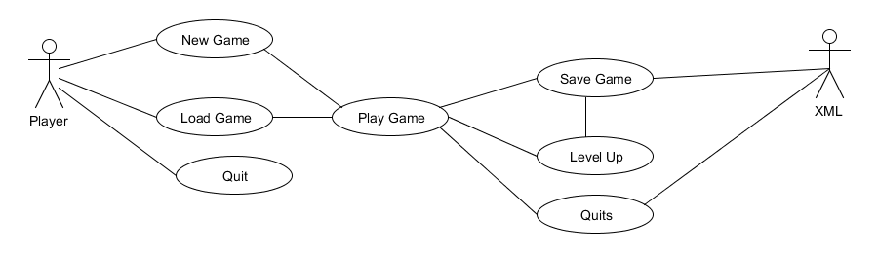

### Requirement 1 <New Game>

#### Description & Priority

The player needs to start a new game as if they haven’t played the game before they need to play the game from the start. If it’s a first time player the will need to start the game from the beginning

#### Use Case

**Scope**

The scope of this use case is to allow player to start a new game.

**Description**

This use case describes the steps involved in starting a new game

**Use Case Diagram**

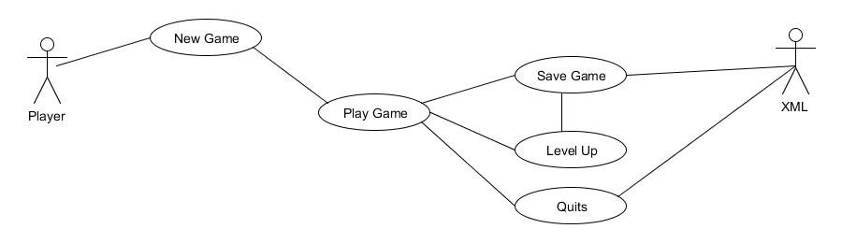

**Flow Description**

**Precondition**

The player has started up the game.

**Activation**

This use case starts when a player started up the game in the main menu.

**Main flow**

1. The player selects new game.
2. Player plays game.
3. Player levels up.
4. Game saves details to xml save file.
5. Player quits out of game.

**Termination**

The system presents the main menu when player quits out of the game.

**Post condition**

The system goes into a wait state

### Requirement 2 <Load Game>

#### Description & Priority

A returning player is allowed to select load game and continue on from where the last left off on their previously saved game.

#### Use Case

**Scope**

The scope of this use case is to allow player to load game.

**Description**

This use case describes the steps for a player to load a previous game.

**Use Case Diagram**

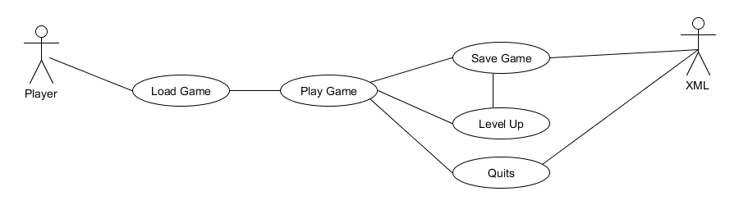

**Flow Description**

**Precondition**

The player has started up the game and has saved file of previous game.

**Activation**

This use case starts when a player started up the game in the main menu.

**Main flow**

1. The player selects Load game from main menu.
2. Player Plays game from where they left off.
3. Player levels up.
4. Game saves details to xml File.
5. Player quits out of game.

**Termination**

Game goes back to main menu.

### Requirement 4 <Quit>

#### Description & Priority

Player wants to leave game and exits the game.

#### Use Case

**Scope**

The scope of this use case is to allow players to quit.

**Description**

This use case describes the steps for a player to quit game.

**Use Case Diagram**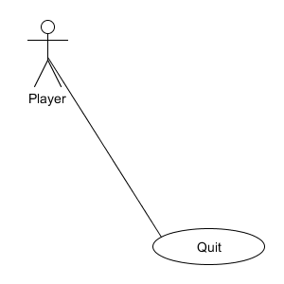

**Flow Description**

**Precondition**

The player has started up the game.

**Activation**

This use case starts when a plyer is in the main menu.

**Main flow**

1. Player selects quit game from main menu.
2. Game turns off and exit to computers home screen

**Termination**

Computer goes to home screen.

## Non-Functional Requirements

### Performance/Response time requirement

When making a game it is important that the game run perfectly and doesn’t slow down. Games need to run at a constant frame rate to ensure there is no lag to ensure smooth gameplay and animations.

Game needs to run perfectly as glitches or bug in games can ruin gameplay and make users less likely to play the game.

### Availability requirement

The game will be built in and for windows but I would like to port to other platforms like Xbox or PlayStation. I would have the game to be able to be downloaded through game streaming services such as steam, Xbox live and PlayStation Store

### Robustness requirement

When running the game should be able to play continuously and not crash.

### Reliability requirement

The game needs to work the same way and have the functionality across all platforms.

### Maintainability requirement

Games can be fixed and repaired through post-release patches downloaded online. These patches can fix and alter any bug, game breaking or exploits in the game. Players will also be able to report any and all bugs to developer to fix.

### Extendibility requirement

When the game is released it is possible to add on additional content through DLC (Downloadable Content). These DLC can contain additional levels not created for the main release or even other game modes.

### Reusability requirement

Games all have common code for movement and fighting if I were making another game. Common scripts can be Collision detection, player movement, camera movement, Attacks and etc.

I wanted to continue development of the game or create a sequel; I could also reuse some of the art assets to keep the game in the same style.

### Resource utilization requirement

The Game will use as much available resources as it requires from the users system to produce a standard of stability and playability.

# Interface requirements

Fight Utopia will be interfaced with an xml file that saves the players stats. I know saving to an xml file isn’t the best approach but I would like to host the game online or even just an online high Score list which the xml file will help to do. I am also working with the oculus rift API to allow my game to be use through the VR head set

## GUI

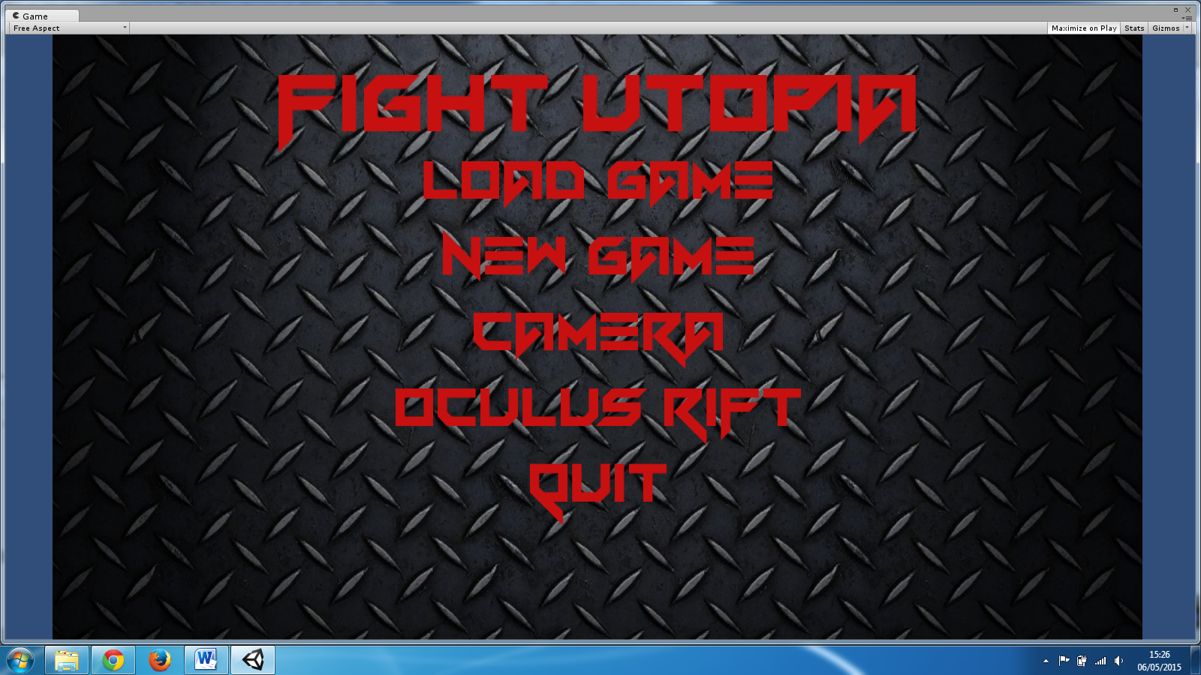

This is the GUI for my main menu, it’s a very simple GUI the load Game and Start game lead you to the fame itself and quit exits out application.



GUI in the with the item your using on the lower left side of the screen. Along with your health, experience points and coins on the lower right side.

# System Architecture

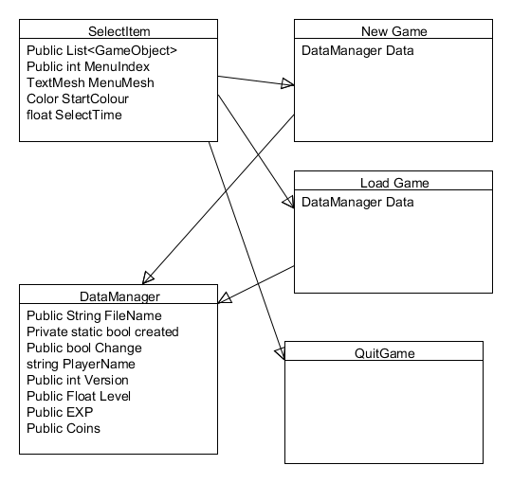

Here is the Class diagram for main menu above.

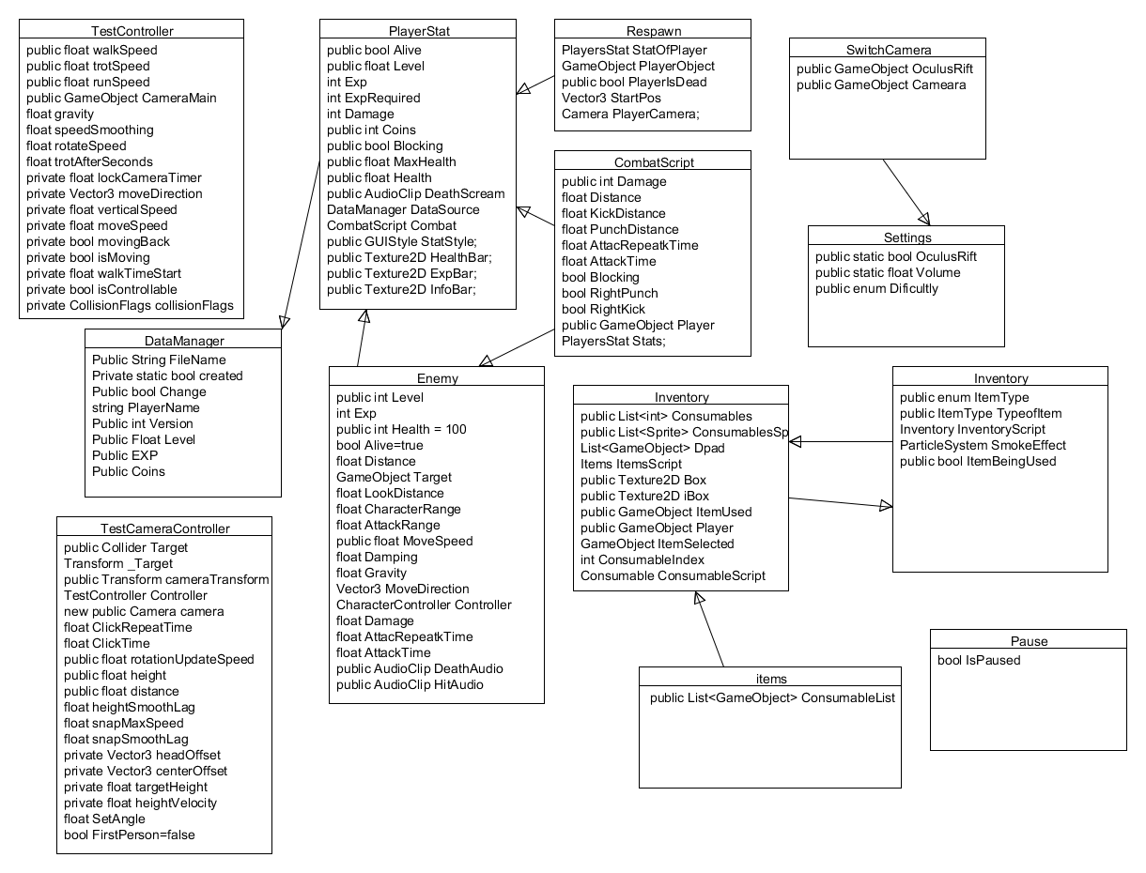

This is the Class diagram for the main game.

# System Evolution

I believe this game might do better as a massive online RPG where players from around the world can fight with or against players from around the world.

## Monthly Journal

Reflective Journal

Student name: Sean Hoey

Programme: BSHC 4 gaming and multimedia

Month: October 2014

**My Achievements**

This month I have done very little towards the project. I’ve created a very simple character out of shapes to start programming and a scene to test my code in. Along with setting up unity to play the game using a controller and coding out some basic movement of the character and the camera. This month I was also introduced to the possibility using the Oculus Rift virtual reality device on my project at the moment I don’t think I can add set it up in my project. I know unity is working on allowing users free or subscribed to integrate the Oculus Rift into any project.

**My Reflection**

I felt that the work I did was done well when I did work. But I do need to start putting in more hours in to working on my project. I think I have already fallen behind for what I want my game to be at the end of the year so I will need to roll up my sleeves and do some serious work on my project. As mentioned I was introduced to the Oculus Rift this month and would like to incorporate the oculus rift into my project as it would be cool to create a virtual realty game.

**Intended Changes**

I intend to do a lot more work on the project working more on the player controller and the fighting system along with combos. I will also look at meeting my project supervisor to talk to him about my project where I am and maybe where to go from here. As well as that I would like to do a few more models for the environment or even a more detailed character model to work with.

Reflective Journal

Student name: Sean Hoey

Programme: BSHC 4 gaming and multimedia

Month: November 2014

**My Achievements**

I was able to integrate the oculus into my project as an SDK was released allowing users with unity free to use oculus. I have added function to switch between first person and third person view. Along with being able to choose at the start of the game if you’re using the oculus as to switch the camera with the oculus cameras. I added small bit of UI just to show at the top of the screen the player’s health along with items that when hit heals the player. I have downloaded some free models of building, walls and trees just to fill out the game environment along with some sounds. I set up a respawn so when the player’s character is killed in the game they are able to restart the level without restarting the game.

**My Reflection**

This month I have worked well and got a good bit done. There is still more to do like animations working more on the fighting system adding in combos and making more than just bashing buttons to hurt the enemy. During the month my laptop crashed and I had to install everything again this has made me think about backing up my work more than ever seeing how easy it was possible losing all my work off my computer and starting from scratch.

**Intended Changes**

To back up my work more often, work on more models that I have created rather than getting them off the internet. Add more functionality and interaction from the player to the game world I am intending on creating. Create some functions for fighting like blocking, dodging and countering.

**Supervisor Meetings**

Date of Meeting: 11/19/2014

Items discussed: We discussed what I did so far in the project and how I’m working with the oculus and idea on how to do an open-world game. Paul also mentioned to do a brood verity of function in the game rather than focus on small detail for this semester so I can show what I could and can do with my project for the project presentation.

Action Items: To add more function into the project.

Reflective Journal

Student name: Sean Hoey

Programme: BSHC 4 gaming and multimedia

Month: December 2014

**My Achievements**

I have added small animations to my character for kicking, punching and blocking. I have looked into a small bit of a saving system with xml and looking on how to have my levelling system working I’m going for having the player gain points by defeating enemies and additional points for highest combo count. I had my midpoint presentation this month I felt it went well and I got good feedback from. She told me to look at my game and get the overall goal of the game is it to reach a certain destination or defeat so many enemies and how does it reward the player as they play.

**My Reflection**

With examining up and other projects due I didn’t get a whole lot done. But what I have done I have felt I am making progress. With the midpoint presentation I have a lot to think about with regards to my game. I need to start looking at more function to reward player and to give them a feedback in some way of how they are playing and how far they are from levelling up or their progression in my game.

**Intended Changes**

To implement a saving system into the game then to add functions to count how many enemies a player fights in one period of combat the players highest combo in that combat period and translate them into EXP for the player. Then when the player does level up to give them a reward if that be a new attack or to make the players attack stronger.

Reflective Journal

Student name: Sean Hoey

Programme: BSHC 4 gaming and multimedia

Month: January 2015

**My Achievements**

This month I didn’t get a lot done at the start of the month with exams and work but I was able to set up a simple inventory system and working on being able to pick up items and use them later in the game. I have downloaded some more models for enemies off opengameart.org a website of free assets for 3d and 2d games. I’m also working on some UI element for the in game pause menu.

**My Reflection**

I believe I need to look into more games that have the same style of game play and start doing some testing to change and see any improvement that regular gamers would suggest to game. I also like to really work on my models and animations as they are quite simple or don’t have any animations on the models.

**Intended Changes**

To create some more character, create a better level design and improve my inventory system. I will also intend to go over my requirement specifications.

**Supervisor Meetings**

Date of Meeting: 29/01/15

Items discussed: We discussed what I have done so far and how I’m working on. We also discussed about what I need to be done Like my inventory system, potions and work on my scoring system to create a more sophisticated system. Paul also suggested going back over my requirement system and to look at my use case diagram.

Action Items: Requirement specification.

Reflective Journal

Student name: Sean Hoey

Programme: BSHC 4 gaming and multimedia

Month: February 2015

**My Achievements**

I been mostly working on my reports for the project and started working on my Analysis and Design report. I didn’t do a whole lot with it as I didn’t understand what I had to do with respects to creating a video game, but after talking to Paul I have a greater understanding to need to be done. I also fixed a few bug that were happening in the game one of these being when I switch to first person to third person or vice versa it would register the button been clicked multiple time now it works perfectly.

**My Reflection**

I feel I have already falling behind on my project and need to but more hours working on my game and putting in more function. I also need to work on my report more than I have been as this month I’ve been focusing on my project for other classes.

**Intended Changes**

I need to work on my time management and look at what project to priorities over the others.

Reflective Journal

Student name: Sean Hoey

Programme: BSHC 4 gaming and multimedia

Month: March 2015

**My Achievements**

I have been mostly creating models for my game finally. I’m creating a better character that before and hopefully I’ll be able to create some good animations with this model. I have also worked more on my usable item in the game to give them some functionality so with my smoke bomb when I throw it it’ll hide the player and slow down the enemies rather than be a just be animation.

**My Reflection**

I feel I’ve done more work than last month but I am still a long way away from being done hopefully after the exams I’ll be able to but full resources behind my project.

**Intended Changes**

To communicate more with my project supervisor as I haven’t meet up with him in a while.

Reflective Journal

Student name: Sean Hoey

Programme: BSHC 4 gaming and multimedia

Month: April 2015

**My Achievements**

I have been focusing on my exams at the start of the month. After my exams I just worked a little bit on my reports. I did a little bit of coding for some of my game. I haven’t done a whole lot this month which is really bad.

**My Reflection**

I feel that I have fallen way behind on what I need to do and need to really get a lot done and try to get as much as I can done before I need everything in.

**Intended Changes**

To work harder and not to be distracted and procrastinate like I have.

## Other Material Used

### Controls

**Triangle=Left punch**

**Circle= Right punch**

**Square= Left kick**

**X=Right kick**

**Left Analog=Movement**

**Right Analog = look around**

**R2=Block**

**R1=Heavy attack**

**R3=switch between first person and third person**

**L2=Run**

**L1=use item**

**D-pad= Select item**